

**Financial Modelling Project**

**(2020-21)**

**SYBSc Finance Semester IV**

**Date of submission: 28th January, 2020**

**The model calculates the WACC for all the stocks listed on NSE using the latest data available being updated daily from various sources with python.**

A028: Ishaan Kesarwani

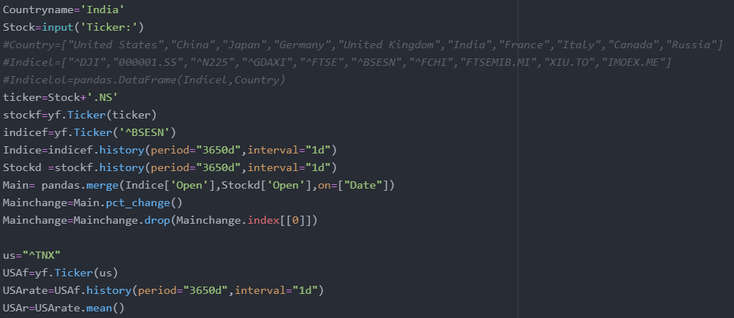

Libraries used: Yahoo Finance, Pandas

This block of code is used for extracting data from the Yahoo Finance library. The stock data is collected for a period of ten years. Using the pandas library, we merge the stock and indices data. The percentage change is also calculated using pct_change. We now extract the ten-year bond yield rate for USA from the Yahoo Finance library with a similar process.

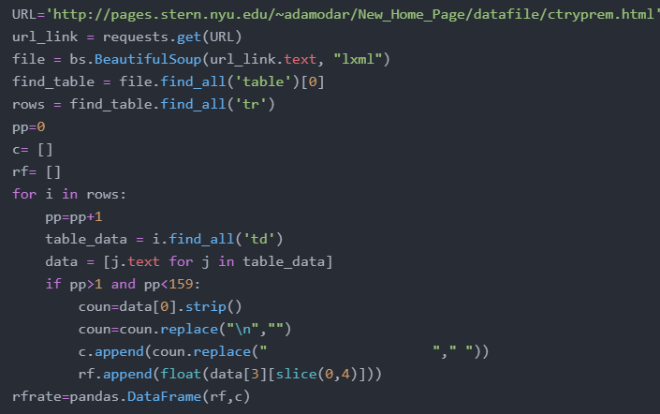

Libraries used: BeautifulSoup, requests

This block of code uses is used for extracting data from the web or 'Web scraping' for the latest Default spread for India based on Moody's ratings.



Required data

It uses the request library to load the page into the programme while Beautiful soup is used to communicate with the HTML language. Here we are extracting the first table and going through all the rows and storing them in a list (a form of collection of data) named c and rf. The rows and cells are stored in the <tr> and <td> tags and we are looking for the data amongst those tags only.

The data as obtained is not useful and needs to be formatted to be useable and searchable for which the extra spaces and \n (HTML Jargon) is removed.

The formatted lists are then combined to form a table or a ‘data table’.

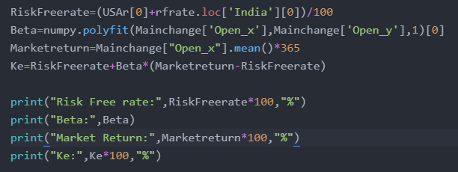

The USA bond yield rate is combined with the sovereign spread of India to get the total risk-free rate, the spread being searched from the table obtained above using the loc function. The beta is calculated using polyfit(Slope in excel) from numpy and the market return by averaging the Sensex column from the table above. All of this is combined to get the Ke and all the values are printed.

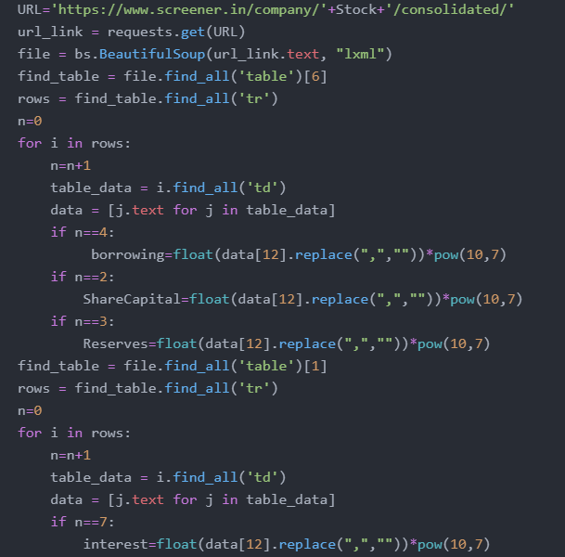

Libraries used: Beautifulsoup, requests.

This block of code is used for extracting data from the web or performing web scraping for computing the amount of borrowings, share capital, reserves and interest.

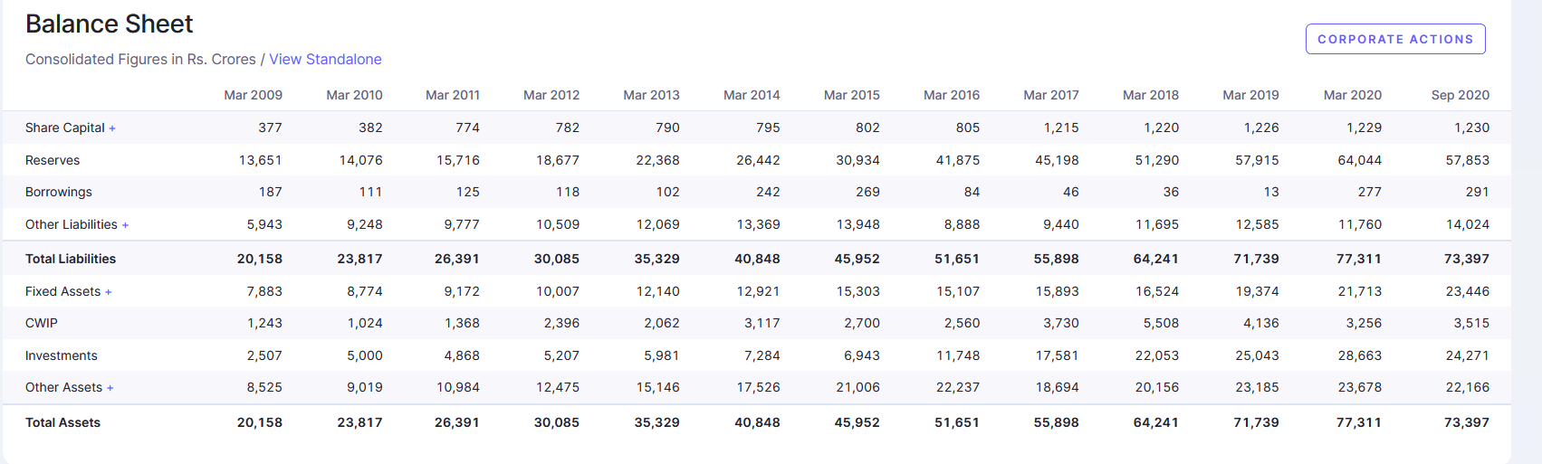Required data

It uses the request library to load the page into the programme while BeautifulSoup is used to communicate with the HTML language. Here we are extracting the 7th table which is used for computing the amount of borrowings, share capital and reserves from the balance sheet and extracting the 1st table for computing the amount of interest from profit and loss respectively on the webpage and going through the rows and storing them. The rows and individual cells are stored between the <tr> and <td> tags and we are looking for the data amongst those tags only. This data which is obtained is not useful by itself and needs to be formatted to be useable and searchable for which the extra spaces and “,” is removed.

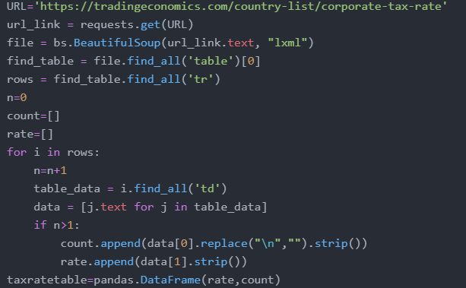

Libraries used: Beautifulsoup, requests

This block is used for extracting data from the web or performing ‘web scraping’ for retrieving the tax rates. This block uses the request library to load the page into the programme while Beautiful soup is used to communicate to the program with the HTML language.

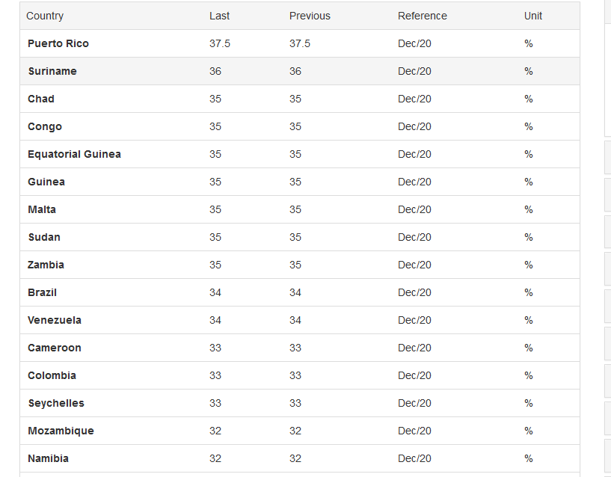

Required data

Here we are extracting the only table on the webpage along with running all the rows and storing them in a list which is a collection of data named ‘count’ and ‘rate’. The rows and individual cells are placed between the <tr> and <td> tags. We are looking for the data which are present amongst the respective tags. The entire data obtained is not useful and has to be formatted in order for it to be used and searchable. In lieu with the same, the extra spaces and \n are replaced by a single space. Pandas is used to combine the entire data we have extracted.

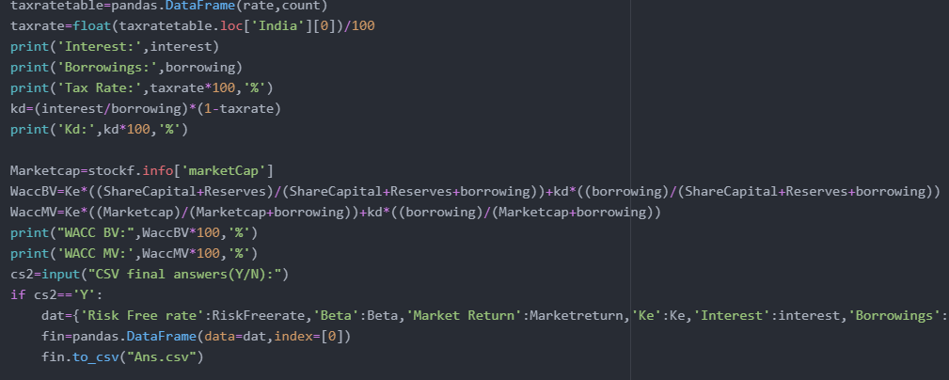

Libraries used: Pandas

Here the tax rate is searched for from the table made above for India and the information and calculations for coast of debt are printed. The market cap is obtained from yahoo finance and finally by combining all of the above the final answers are calculate for both book and market value. The if function is used for obtaining all of the answers in a CSV format.

Note: The explanation above doesn’t aim to recreate how to create the model itself since that can be done by simply copying it, but it aims to explain the reason for which each code block is used.